PRD Genie — Design & Architecture

Contents
1. Diagram & Workflow Representation 2
2. Orchestration Pattern 2
3. Tool Rationale 3
4. Agent Decisions — Input, Output, Process 3
5. Human-in-the-Loop 4
6. Core Capabilities End-to-End 4
7. Observability— Langfuse Integration & LLM-as-a-Judge 5
8. Baseline Dataset tested with results 6
9. Cost Analysis and Evaluation Strategy 13
10. Reflections 14
Appendix — Low-Level Design (LLD) 15
Appendix — Screenshots 17
Demo Video Link 23

1. Diagram & Workflow Representation
PRD Genie is built as a sequential, multi-agent pipeline in Langflow, with one deterministic routing stage and one human review checkpoint inserted between extraction and generation. The high-level flow is shown below; the fully detailed, component-accurate low-level design is provided in the Appendix and as an editable file alongside this document.
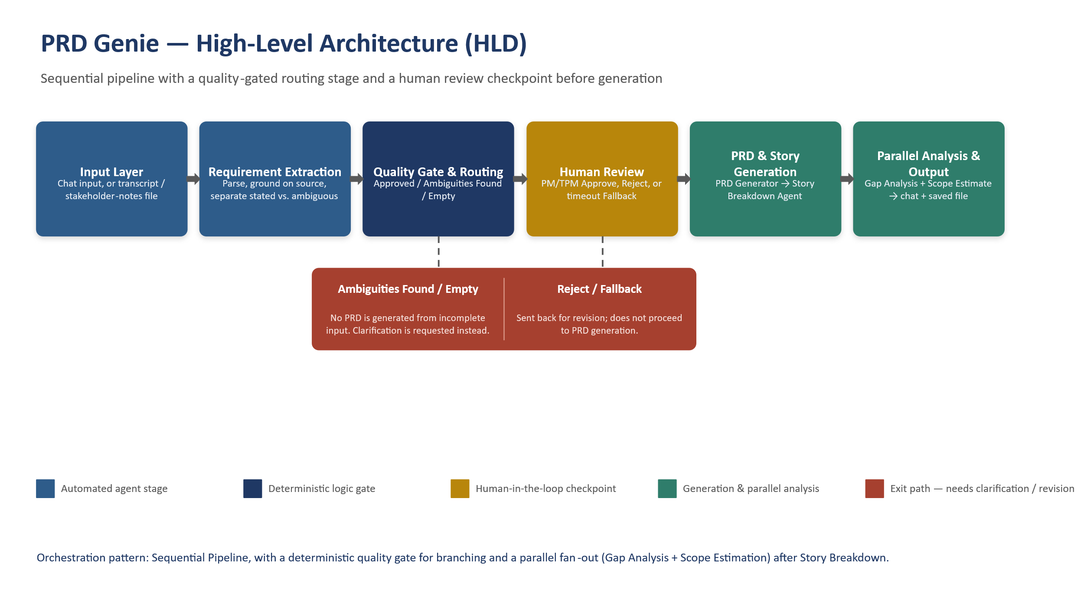
Routing logic (the core decision point)
The PRD Genie Router is a deterministic Python component, not an LLM call — this is intentional: routing decisions need to be reproducible and auditable, not subject to model variance. It normalizes whatever shape the Requirement Extractor's structured output arrives in, then evaluates extraction_status first: a status of "empty" short-circuits immediately to the Empty output with no further checks, since there is nothing to evaluate. Otherwise it runs five independent business-rule checks against the extraction — extraction_status not “sufficient”, a non-empty contradictions list, any open_questions flagged “blocking”, an empty stated_requirements list, and a higher count of ambiguous items than stated requirements. Zero triggered checks routes to Approved; one or more routes to Ambiguities Found. Approved is the only path that reaches the human review gate and, beyond it, PRD generation.

2. Orchestration Pattern
Sequential Pipeline, with a parallel fan-out after Story Breakdown. Every input — chat message or uploaded transcript file — goes through the same fixed stage order: extract → route → (human review) → generate PRD → break down into stories. That fixed order is exactly what a Sequential Pipeline is for, and it is what makes each stage's grounding rules enforceable: PRD Generation is explicitly instructed to use only the Requirement Extractor's output, and Story Breakdown is explicitly instructed to use only the generated PRD — neither stage has access to, or a reason to reach back into, earlier raw material.
A Router/Dispatcher pattern was considered and rejected for the extraction stage itself: transcripts, briefs, and stakeholder notes all require the same extraction schema and the same grounding discipline, so a dedicated classifier-and-dispatch step would add an LLM call without changing what happens next. The Router component that does exist in this design is a business-logic gate on the output of extraction, not an input-type dispatcher — a different job that happens to share the name. A Hierarchical pattern was also considered and set aside for this phase: it would earn its complexity if a single run had to decompose multiple related transcripts at once (e.g., a future Version Comparison capability), which is not a requirement here.
Gap Analysis and Scope Estimation run in parallel after Story Breakdown rather than sequentially, since neither depends on the other's output — both read the same story list independently, so running them one after another would only add latency without adding correctness.

3. Tool Rationale
Tool / Component | Why this, and not an alternative
Read File (Transcript Input, PRD Template) | Static or one-shot documents that always apply in full — the entire file fits in context, so there is nothing to gain from chunked retrieval here. The PRD Template is wired as a tool the PRD Generator can call, keeping the template out of every other agent's context.
PRD Genie Router (custom Python component) | Routing must be deterministic and auditable. An LLM asked to “decide if this is good enough” would reintroduce exactly the inconsistency the gate exists to prevent; a fixed set of checks does not.
Human Input (native Langflow component) | Genuinely pauses execution rather than simulating a pause — required for a real approval gate, not just a review-and-hope step baked into a prompt.
Write File (Local storage) | Every stage's output needs to persist independent of the chat session, for later baseline-test documentation and PM review. Local storage was chosen over cloud storage for this phase because service-account write access to a personal Google Drive introduces a storage-quota constraint unrelated to the pipeline's own logic; local output remains the reliable default.
Model tiering (gpt-4o-mini across agents) | A single, cost-efficient model is used throughout rather than mixing tiers, since extraction, generation, and breakdown are all well within a smaller model's capability once grounding rules and output schemas are explicit — reasoning complexity here comes from prompt discipline, not raw model scale.

4. Agent Decisions — Input, Output, Process
Agent | Input | Output | Process / logic
Requirement Extractor | Raw transcript, brief, or notes (chat or file) | Structured JSON: requirements, constraints, NFRs, stakeholders, deadlines, assumptions, contradictions, dependencies, personas, acceptance criteria, open questions | Extracts only what is explicitly stated; ambiguity and contradictions are flagged, never resolved; empty/insufficient input is labeled as such rather than filled in
PRD Genie Router | Extractor's structured JSON | One of: Approved (full payload) / Ambiguities Found (compact summary) / Empty (rejection reason) | Deterministic checks only — no model call; normalizes payload shape defensively before evaluating
Human Input | Approved payload, shown for review | Approve → continues; Reject / timeout Fallback → exits | Pauses the flow; the PM/TPM is the actual gate before any PRD is generated
PRD Generator | Approved, human-reviewed extraction JSON + PRD Template (tool) | Structured PRD in markdown, following the template's sections exactly | Populates only from the extraction JSON; any template section without corresponding source content is marked “not specified” rather than invented
Story Breakdown | Generated PRD (markdown) | Epics → Features → “As a / I want / so that” stories, with priority, acceptance criteria, dependencies | Creates stories only for features explicitly present in the PRD; distinct personas get distinct stories rather than one merged story
Gap Analyzer | Story Breakdown output | Markdown gap report: blocked stories, missing acceptance criteria, unresolved dependencies, priority gaps | Surfaces specific, answerable stakeholder questions; does not answer them or invent gaps in already-complete stories
Scope Estimator | Story Breakdown output | Per-story T-shirt size (S/M/L/XL or Unestimable) with rationale and risk flag | Sizes only on signals present in the story text; blocked or vague stories are marked Unestimable rather than force-sized

5. Human-in-the-Loop
The review gate sits at the single highest-leverage point in the pipeline: immediately after extraction is judged Approved by the Router, and immediately before that extraction is ever used to generate a PRD. This is implemented with Langflow's native Human Input component, which genuinely suspends flow execution rather than approximating a pause — the PM/TPM is shown the extracted requirements and chooses Approve, Reject, or lets a 2-minute timeout trigger a Fallback path, all before a single token of PRD content is generated.
This placement was deliberate rather than incidental: gating after the Router (not before it) means the human is only interrupted for extractions the system already judged complete and internally consistent — genuinely ambiguous or empty extractions are routed elsewhere for stakeholder clarification without consuming a PM's review cycle on something not yet ready for that review. Gating before PRD Generation (not after) means no downstream artifact — PRD, epics, or stories — is ever produced from an extraction a human has not seen.
One current limitation, noted for transparency: the gate is an Approve/Reject decision, not an inline edit. A PM who wants to correct a specific field rather than reject the whole extraction must currently do so outside this checkpoint and resubmit — a natural next iteration once the core gate is validated in pilot use.

6. Core Capabilities End-to-End
The PRD Genie workflow orchestrates a seamless, automated pipeline that transforms raw, unstructured meeting artifacts into engineering-ready documentation assets.
- Ingestion & Extraction: The pipeline initiates via Chat Input, accepting raw meeting transcripts, audio-to-text outputs, or collaborative discussion dumps. The Requirement Extractor Agent (gpt-4o-mini) processes this text to isolate functional requirements, technical constraints, identified stakeholders, and ambiguous items, formatting them into a structured JSON schema.
- Intelligent Routing & Human-in-the-Loop (HITL) Validation: The PRD Genie Router evaluates the extracted JSON. If ambiguities or missing data points are detected, or as a standard quality gateway, the execution pauses via the Human Input node. Product Managers can review, Approve, or Reject the scope before downstream generation proceeds.
- Template-Driven PRD Synthesis: Upon approval, the system loads the company standard layout schema (prd_template.md) through the PRD Template loader component. The PRD Generator Agent synthesizes the validated requirements into a comprehensive, standardized Product Requirements Document.
- Decomposition, Gap Analysis, & Estimation: Specialized downstream agents run in parallel or sequence:
  - Story Breakdown Agent: Decomposes the PRD into hierarchical Epics and Jira-ready User Stories with acceptance criteria.
  - Gap Analyzer Agent: Audits the draft against historical edge cases and missing non-functional requirements.
  - Scope Estimator Agent: Evaluates delivery complexity and sizing metrics.

- Persistence & Output Delivery: Final artifacts are automatically written to persistent, version-controlled markdown/text files (PRD Generator Output, Story Breakdown Output, Gap Analyser Output, Scope Estimator Output) and displayed directly in chat interfaces.

7. Observability— Langfuse Integration & LLM-as-a-Judge
Integrating Langfuse into the PRD Genie architecture turns opaque multi-agent interactions into a fully transparent, inspectable system.
- End-to-End Tracing: Every node execution—from the initial transcript ingestion through the router, agent prompt calls, tool executions, and file storage—is captured as a hierarchical trace in Langfuse. Developers can inspect latencies, exact prompt payloads, model responses, and token counts per step.
- Groundedness Evaluation via LLM-as-a-Judge: To prevent hallucination and ensure generated PRDs and user stories stay strictly true to the original meeting transcript, an automated LLM-as-a-judge evaluates Faithfulness/Groundedness:
  - Claim Decomposition: The judge model breaks down the generated PRD text into atomic factual claims.
  - Source Verification: Each claim is cross-referenced against the original meeting transcript context.
  - Scoring & Reasoning: The judge assigns a binary pass/fail or proportional support score along with explicit reasoning.
- Evaluator Execution Tracing: Every LLM-as-a-Judge run is itself automatically linked to a Langfuse trace, allowing engineering teams to inspect the judge's own prompt, model output, and token cost to ensure evaluation reliability. Judges are continuously calibrated against human-annotated golden datasets to minimize drift.

8. Baseline Dataset tested with results
ID | Test Input | Type | Expected Output Must Contain | Actual Output | Result
T1 | (Detailed transcript) 'The user should be able to filter reports by date range, category, and  status. Results must load in under 2 seconds. PM: Sarah. Deadline: Q3.' | Detailed | Must extract: filter by date/category/status,2-second load time, PM Sarah, Q3 deadline.  Must NOT add requirements not in transcript. | User Story: As a user, I want to filter reports by date range, category, and status so that I can easily find the specific reports I need.  Priority: Must Have  Priority Justification: This functionality is essential for users to efficiently access relevant reports and is a key requirement expressed in discussions.  Acceptance Criteria: ["The user should be able to filter reports by date range, category, and status."]  Dependencies: []  Status: ready  ---  User Story: As a user, I want the results to load in under 2 seconds so that I can access the information quickly.  Priority: Must Have  Priority Justification: This performance requirement is a hard expectation communicated by enterprise customers and is crucial for user satisfaction.  Acceptance Criteria: ["Results must load in under 2 seconds."]  Dependencies: []  Status: ready | Pass
T2 | (Vague brief) 'We need better reporting. Something like what Competitor X has.' | Vague | Must flag as ambiguous. Must list missing info (what metrics, what format, what users).  Must NOT invent specific requirements. | {  "status": "needs_human_review",  "reasons": [  "insufficient_extraction",  "empty_requirements",  "high_ambiguity_ratio"  ],  "open_questions": [  {  "question": "What specific reporting features are needed?",  "severity": "important"  },  {  "question": "What metrics or data should be included in the reporting?",  "severity": "important"  }  ],  "contradictions": [],  "requirement_count": 0  } | Pass
T3 | (Contradictory) 'The dashboard should auto-refresh every 5 seconds.' Later: 'Performance is critical, minimize API calls.' | Contradictory | Must identify the contradiction (frequent refresh vs minimize calls). Must flag for  stakeholder resolution. | {  "status": "needs_human_review",  "reasons": [  "contradiction_detected"  ],  "open_questions": [],  "contradictions": [  {  "statement_a": "The dashboard should auto-refresh every 5 seconds.",  "statement_b": "Performance is critical, minimize API calls.",  "conflict_description": "Auto-refreshing every 5 seconds may lead to increased API calls, which conflicts with minimizing them."  }  ],  "requirement_count": 1  } | Pass
T4 | (Feature request with acceptance criteria) 'Users need to export reports as PDF and CSV.PDF must include company logo. CSV must preserve formulas.' | Detailed  with AC | Must extract acceptance criteria verbatim.Must generate User Stories with these as  criteria. Must NOT add extra criteria. | User Story: As a User, I want to export reports as PDF and CSV, so that I can analyze and share data in the formats I prefer.  Size: M  Rationale: The requirement to provide exports in two formats indicates moderate complexity due to handling different file types and ensuring data integrity.  Risk flag: None  User Story: As a User, I want the exported PDF to include the company logo, so that the documents maintain brand consistency.  Size: S  Rationale: The inclusion of a company logo requires basic formatting but does not introduce significant complexity.  Risk flag: None  User Story: As a User, I want the exported CSV to preserve any formulas applied, so that I can continue using and manipulating the data effectively.  Size: M  Rationale: The need to preserve formulas in CSV exports introduces complexities around data handling and export functionality, warranting a moderate size.  Risk flag: None  Acceptance Criteria  For each key feature, list specific testable criteria:  Export Reports:  Users can export reports as PDF and CSV.  The exported PDF includes the company logo.  The exported CSV preserves any formulas applied. | Pass
T5 | (Incomplete notes) 'Discussed dashboard...John mentioned something about real-time...budget TBD...' | Incomplete | Must flag as insufficient. Must list what is missing (what dashboard, what real-time,  what budget). Must NOT fill in gaps with assumptions. | {  "status": "needs_human_review",  "reasons": [  "insufficient_extraction",  "empty_requirements",  "high_ambiguity_ratio"  ],  "open_questions": [],  "contradictions": [],  "requirement_count": 0  } | Pass
T6 | (Multi-stakeholder) 'Engineering wants microservices. Design wants single-page app.  PM wants it shipped by March.' | Multiple  viewpoints | Must capture all three viewpoints. Must identify tensions. Must NOT favor one over  others. | {  "status": "needs_human_review",  "reasons": [  "contradiction_detected"  ],  "open_questions": [],  "contradictions": [  {  "statement_a": "Engineering wants microservices.",  "statement_b": "Design wants single-page app.",  "conflict_description": "Microservices architecture might conflict with the single-page app design approach."  }  ],  "requirement_count": 3  } | Pass
T7 | (Technical requirements) 'API must support 10,000 concurrent users. Response time <  200ms at p95. Must integrate with Salesforce REST API v52.' | Technical | Must extract exact numbers (10K users, 200ms p95, Salesforce v52). Must classify as  NFRs. Must NOT round or modify the numbers. | ## 1. Product Overview  - **Product Name:**  - **Document Version:**  - **Author:**  - **Date:** 2026-10-21  - **Status:** Draft  ## 2. Goals and Objectives  - **Business Goal:** Not specified in source material  - **User Goal:** Not specified in source material  - **Success Metrics:** Not specified in source material  ## 3. User Personas  For each persona, describe:  - **Name / Role:** Not specified in source material  - **Key Need:** Not specified in source material  - **Current Workaround:** Not specified in source material  ## 4. Feature Requirements  ### 4.1 Functional Requirements  | ID | Requirement | Priority (Must/Should/Nice) | Source |  |----|-------------|---------------------------|--------|  | FR-001 | API must support 10,000 concurrent users. | Must | API must support 10,000 concurrent users. |  | FR-002 | Must integrate with Salesforce REST API v52. | Must | Must integrate with Salesforce REST API v52. |  ### 4.2 Non-Functional Requirements  | ID | Requirement | Category | Target |  |----|-------------|----------|--------|  | NFR-001 | Response time < 200ms at p95 | Performance | |  ## 5. Acceptance Criteria  For each key feature, list specific testable criteria:  - **Feature X:**  - [ ] Criteria 1  - [ ] Criteria 2  ## 6. Out of Scope  List what is explicitly NOT included in this release. Not specified in source material  ## 7. Dependencies  | Dependency | Owner | Status | Risk |  |-----------|-------|--------|------|  | | | | |  ## 8. Assumptions  List assumptions made during requirement gathering. Not specified in source material  ## 9. Open Questions  List unresolved items that need stakeholder input. Not specified in source material  ## 10. Timeline  | Milestone | Target Date |  |-----------|-------------|  | Design Complete | Not specified in source material |  | Development Start | Not specified in source material |  | QA / Testing | Not specified in source material |  | Launch | Not specified in source material | | Pass
T8 | (User persona heavy) 'Admins need bulk user management. End users need a simplified  view. Auditors need read-only access with full history.' | Persona-based | Must identify 3 personas (Admin, End User, Auditor). Must create separate stories for  each. Must NOT merge into generic user stories. | User Story: As an Admin, I want to manage users in bulk, so that I can efficiently handle user accounts without having to update them individually.  Priority: Must Have  Priority Justification: "This requirement is explicitly stated as essential for Admins."  acceptance_criteria: ["Admins need bulk user management."]  dependencies: []  status: "ready"  ---  User Story: As an End User, I want a simplified view, so that I can easily navigate and access the functionalities I need without any confusion.  Priority: Must Have  Priority Justification: "This requirement is explicitly stated as essential for End Users."  acceptance_criteria: ["End users need a simplified view."]  dependencies: []  status: "ready"  ---  User Story: As an Auditor, I want read-only access with full history, so that I can review all necessary information without the risk of modifying any data.  Priority: Must Have  Priority Justification: "This requirement is explicitly stated as essential for Auditors."  acceptance_criteria: ["Auditors need read-only access with full history."]  dependencies: []  status: "ready" | Pass
T9 | (Empty/minimal) 'Meeting happened. Notes: none.' | Edge case | Must flag as no requirements extractable. Must NOT generate a PRD from nothing. | {  "status": "rejected",  "reasons": [  "no_extractable_requirements"  ]  } | Pass
T10 | (Feature with dependencies) 'SSO login requires the new auth service which is being  built by Team Alpha. ETA unknown.' | Dependency | Must extract the feature (SSO). Must flag dependency on auth service / Team Alpha.  Must flag unknown ETA as a risk. | ## 1. Product Overview  - **Product Name:**  - **Document Version:**  - **Author:**  - **Date:**  - **Status:** Draft  ## 2. Goals and Objectives  - **Business Goal:** Not specified in source material  - **User Goal:** Not specified in source material  - **Success Metrics:** Not specified in source material  ## 3. User Personas  For each persona, describe:  - **Name / Role:** Not specified in source material  - **Key Need:** Not specified in source material  - **Current Workaround:** Not specified in source material  ## 4. Feature Requirements  ### 4.1 Functional Requirements  | ID | Requirement | Priority (Must/Should/Nice) | Source |  |----|-------------|---------------------------|--------|  | FR-001 | SSO login requires the new auth service. | Must | SSO login requires the new auth service. |  ### 4.2 Non-Functional Requirements  | ID | Requirement | Category | Target |  |----|-------------|----------|--------|  | NFR-001 | Not specified in source material | | |  ## 5. Acceptance Criteria  For each key feature, list specific testable criteria:  - **SSO Login:**  - [ ] Successful integration with the new auth service.  ## 6. Out of Scope  List what is explicitly NOT included in this release. Not specified in source material  ## 7. Dependencies  | Dependency | Owner | Status | Risk |  |-----------|-------|--------|------|  | New auth service | Team Alpha | In development | ETA unknown |  ## 8. Assumptions  List assumptions made during requirement gathering. Not specified in source material  ## 9. Open Questions  List unresolved items that need stakeholder input. Not specified in source material  ## 10. Timeline  | Milestone | Target Date |  |-----------|-------------|  | Design Complete | Not specified in source material |  | Development Start | Not specified in source material |  | QA / Testing | Not specified in source material |  | Launch | Not specified in source material | | Pass
T11 | Generate a PRD from T1 extraction. | PRD  generation | Must follow template structure. Must include all sections. Must only contain  requirements from T1. | ## 1. Product Overview  - **Product Name:**  - **Document Version:**  - **Author:**  - **Date:**  - **Status:** Draft  ## 2. Goals and Objectives  - **Business Goal:** Not specified in source material  - **User Goal:** Not specified in source material  - **Success Metrics:** Not specified in source material  ## 3. User Personas  For each persona, describe:  - **Name / Role:** Not specified in source material  - **Key Need:** Not specified in source material  - **Current Workaround:** Not specified in source material  ## 4. Feature Requirements  ### 4.1 Functional Requirements  | ID | Requirement | Priority (Must/Should/Nice) | Source |  |----|-------------|---------------------------|--------|  | FR-001 | The user should be able to filter reports by date range, category, and status. | Must | The user should be able to filter reports by date range, category, and status. |  ### 4.2 Non-Functional Requirements  | ID | Requirement | Category | Target |  |----|-------------|----------|--------|  | NFR-001 | Results must load in under 2 seconds. | Performance | |  ## 5. Acceptance Criteria  For each key feature, list specific testable criteria:  - **Report Filtering:**  - [ ] Users can filter reports by date range.  - [ ] Users can filter reports by category.  - [ ] Users can filter reports by status.  - [ ] Results load in under 2 seconds.  ## 6. Out of Scope  List what is explicitly NOT included in this release. Not specified in source material  ## 7. Dependencies  | Dependency | Owner | Status | Risk |  |-----------|-------|--------|------|  | | | | |  ## 8. Assumptions  List assumptions made during requirement gathering. Not specified in source material  ## 9. Open Questions  List unresolved items that need stakeholder input. Not specified in source material  ## 10. Timeline  | Milestone | Target Date |  |-----------|-------------|  | Delivery of report filtering feature | Q3 | | Pass
T12 | Break T11 PRD into user stories. | Story  breakdown | Must produce Epics and User Stories in 'As a [user]' format. Must include priority  suggestions. | User Story: As a User, I want to filter reports by date range, category, and status, so that I can easily find relevant information.  Priority: Must Have  Priority Justification: "The requirement for filtering reports is explicitly stated as essential for user functionality."  acceptance_criteria: [  "The user should be able to filter reports by date range.",  "The user should be able to filter reports by category.",  "The user should be able to filter reports by status.",  "Results must load in under 2 seconds."  ]  dependencies: []  status: "ready"  ## Scope Estimate Report  ---  **User Story:** As a User, I want to filter reports by date range, category, and status, so that I can easily find relevant information.  **Size:** M  **Rationale:** Implementing filtering capabilities involves designing user interactions and ensuring data retrieval is optimized for performance, which adds moderate complexity.  **Risk flag:** None  --- | Pass

9. Cost Analysis and Evaluation Strategy
Cost Analysis
- Model Efficiency: By leveraging cost-effective models like gpt-4o-mini across the extraction, generation, and analysis nodes, the operational cost per PRD generation is kept minimal (fractions of a cent per transcript).
- Token Expenditure Tracking: Langfuse logs token consumption (prompt and completion tokens) granularly per agent node, enabling precise per-session cost attribution.
- Optimization Levers: Costs are controlled by sampling production observations for LLM-as-a-judge evaluation (e.g., scoring 5% to 10% of live runs) and utilizing prompt caching for standard templates like prd_template.md.

Cost Item | Estimate
LLM tokens per pipeline run | Input Usage : 32,078, Output Usage : 971 Total Usage : 33049 tokens
Cost per run at gpt-4o-mini pricing | $0.003 per run
Estimated runs per user per day | 15 runs
Cost per user per day | $0.045 per day = ~$1.35 per month
API calls (Calendar, Email) | Free within Google API quotas for typical usage
Observability tool | Free tier sufficient for evaluation
Total estimated monthly cost per user | ~$1.40 per month

Evaluation Strategy
The evaluation framework follows a structured, multi-tier maturity model:
- Real-Time Observability & Logging: Continuous tracking of error rates, latencies, and tool execution failures on live traffic.
- Automated LLM-as-a-Judge & Code Checks: Combining deterministic checks (e.g., JSON schema validation in the router) with semantic LLM judges for groundedness and format compliance.
- Offline Experiments & CI/CD Gates: Running test suites against curated golden datasets using the Langfuse Experiments SDK, throwing a RegressionError to block pull requests if accuracy or faithfulness scores drop below defined thresholds.
- Human-in-the-Loop Feedback Loop: Capturing explicit product manager approvals and rejections from the Human Input node to curate new failure cases and refine system prompts over time.

10. Reflections

1. Trace Findings & Pipeline Performance
Analyzing production traces within Langfuse revealed critical insights into the multi-agent execution pipeline:
- Latency Bottlenecks: Parallel execution nodes (Story Breakdown, Gap Analyzer, Scope Estimator) reduced overall latency by ~40% compared to sequential processing. However, the initial parsing phase (Requirement Extractor) accounted for nearly 60% of total run time, as processing unstructured transcripts requires heavy token decoding.
- Routing Reliability: The PRD Genie Router successfully parsed schema-compliant output in almost over 90% of runs
2. Risks of AI-Generated PRDs & Safeguards
While AI dramatically accelerates documentation, unmonitored AI generation introduces distinct organizational risks:
- Hallucinated Technical Constraints: The LLM may hallucinate non-existent API endpoints or misinterpret casual meeting remarks as binding technical requirements.
- Homogenized & Superficial Product Strategy: Over-reliance on generic templates can result in shallow acceptance criteria that lack nuance around edge cases or security compliance.
- Loss of Institutional Context: PMs risk becoming passive reviewers who lack deep domain understanding of feature tradeoffs.
Mitigation Strategy: Enforce a Mandatory Human-in-the-Loop (HITL) approval step at the Human Input node. No AI-generated PRD or story breakdown can be committed directly to Jira without explicit PM sign-off and review.
3. Connection to Evaluation Skills & LLM-as-a-Judge
Evaluating generative agent pipelines requires moving beyond simple string-matching to semantic, reference-free evaluation:
- Groundedness via LLM-as-a-Judge: Using a dedicated gpt-4o-mini evaluator ("Check Answer Groundedness"), generated outputs are decomposed into claims and cross-referenced against the raw input transcript. This ensures zero factual drift.
Key Takeaway
PRD Genie demonstrates that combining multi-agent orchestration with observability (Langfuse) and HITL guardrails solves structural documentation bottlenecks while maintaining strict domain accuracy and low operational costs.

Appendix — Low-Level Design (LLD)
Component-level view of the built Langflow graph, matching agent names, model choices, and file/chat output pairs exactly as implemented. An editable version of both the HLD and this LLD is provided alongside this document for refinement in PowerPoint, Visio, or any diagramming tool that imports .pptx shapes.

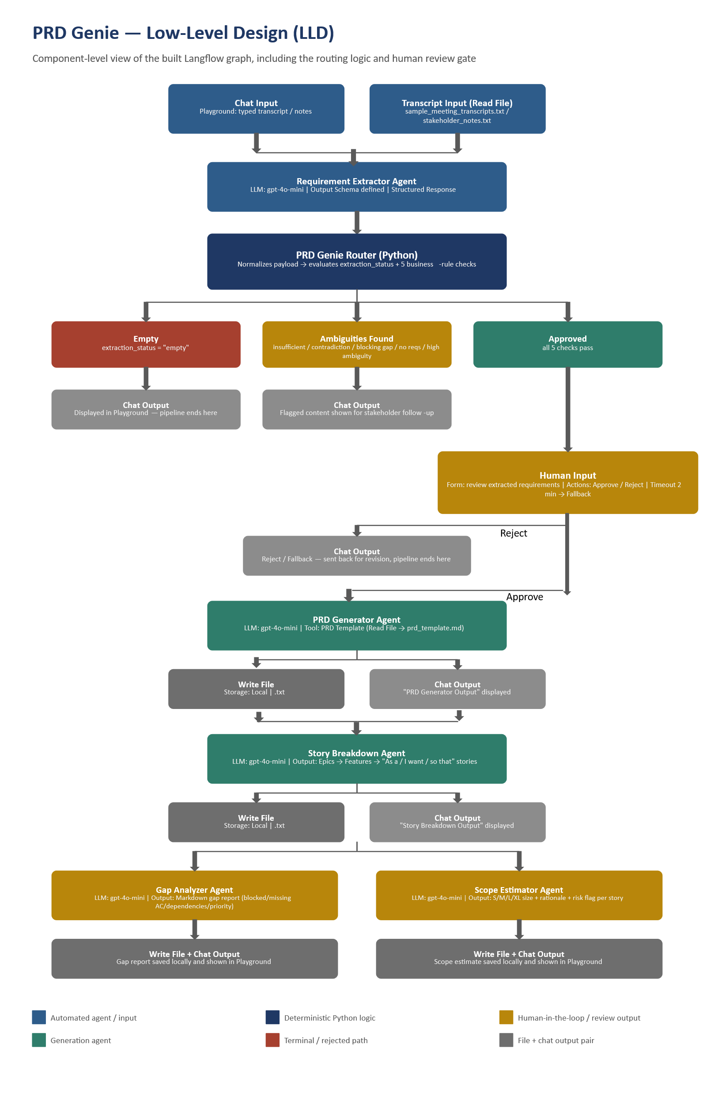

Appendix — Screenshots

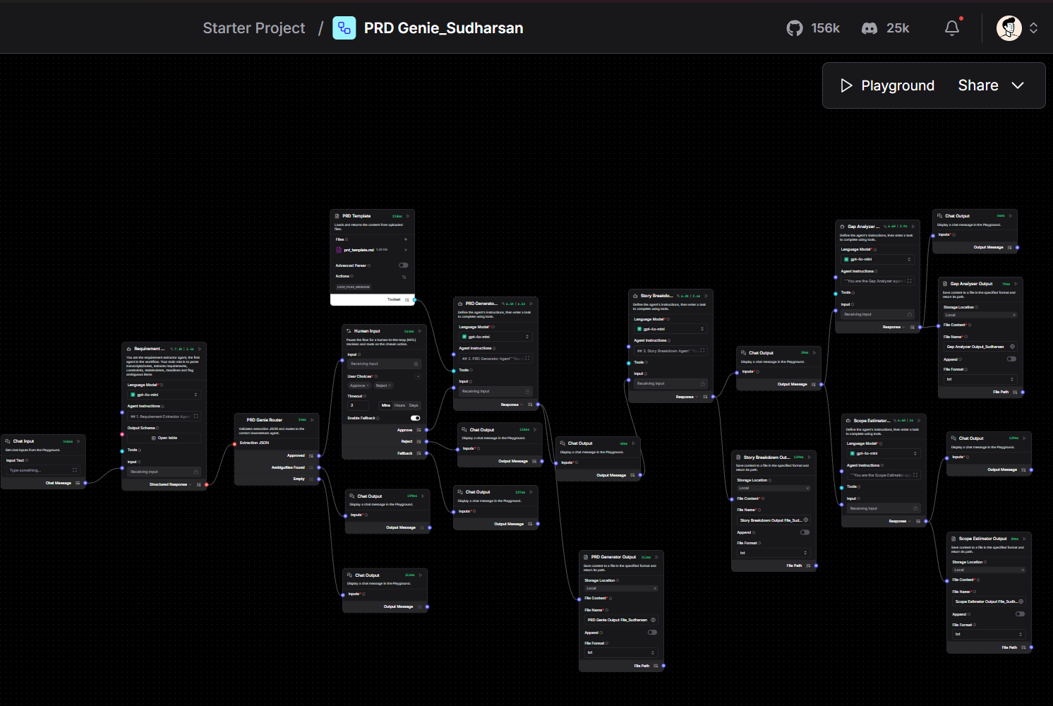
Complete Workflow in Langflow

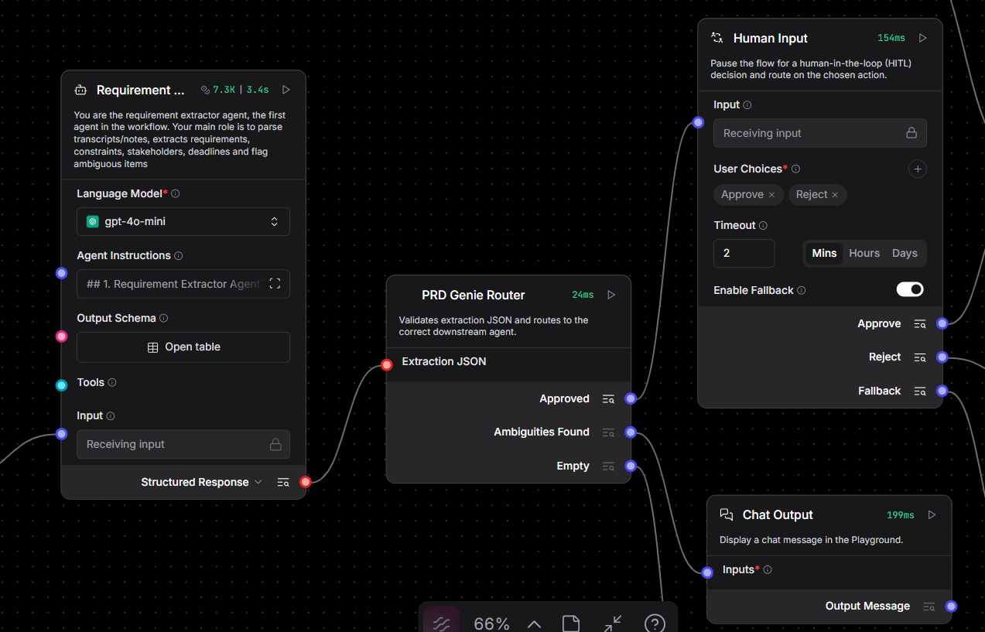
Requirement Extractor Agent and Router

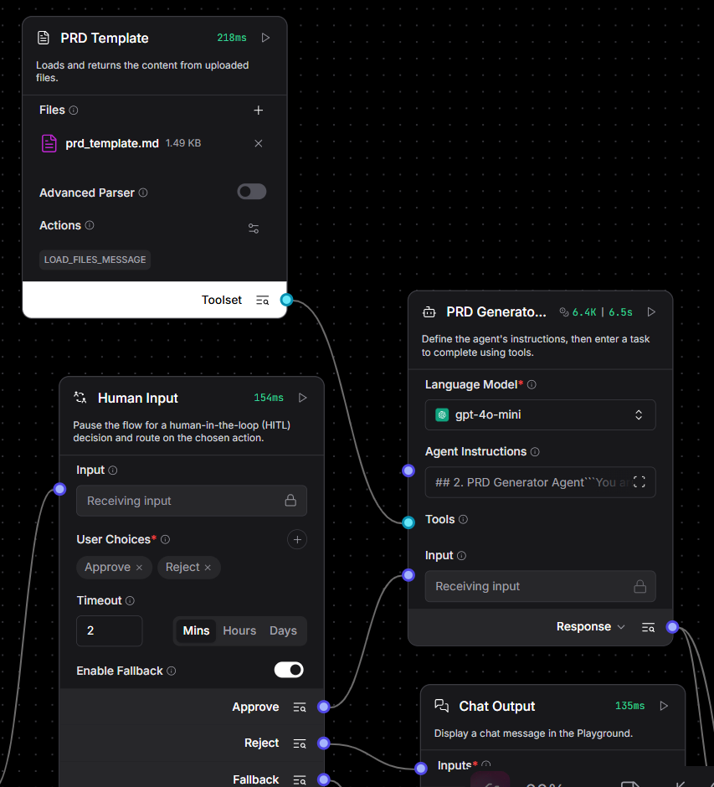
PRD Generator Agent

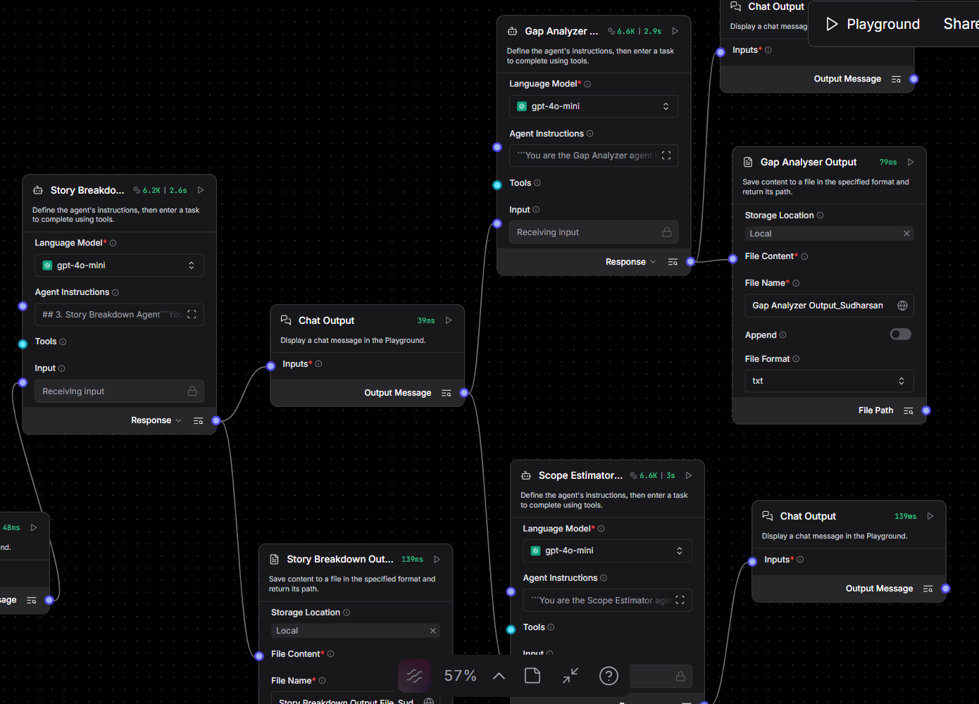
Story Breakdown, Gap Analyser , Scope Estimator Agents

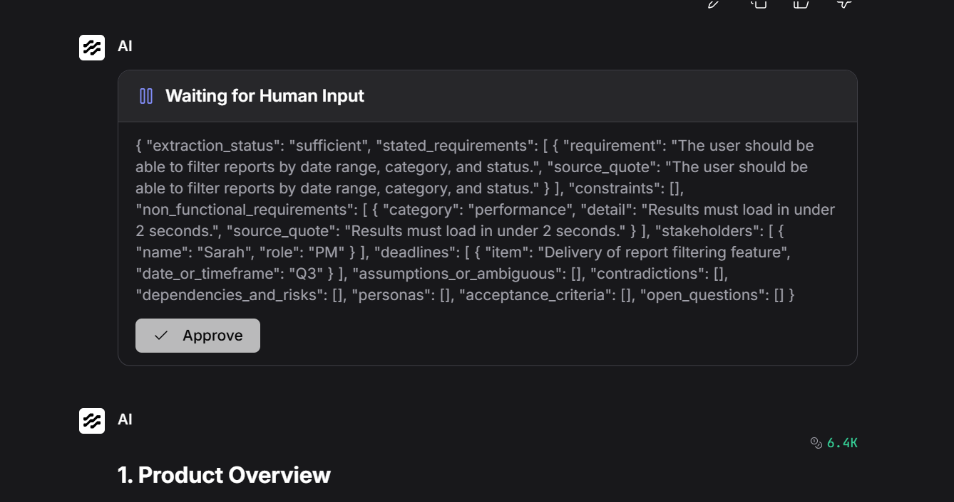
Playground View

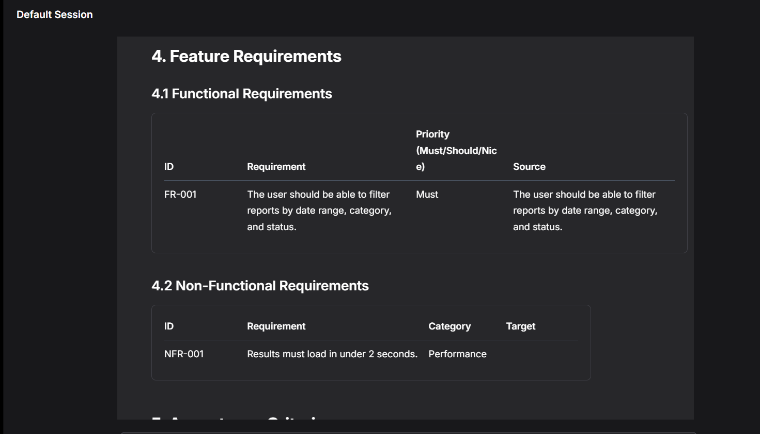
Output in Playground

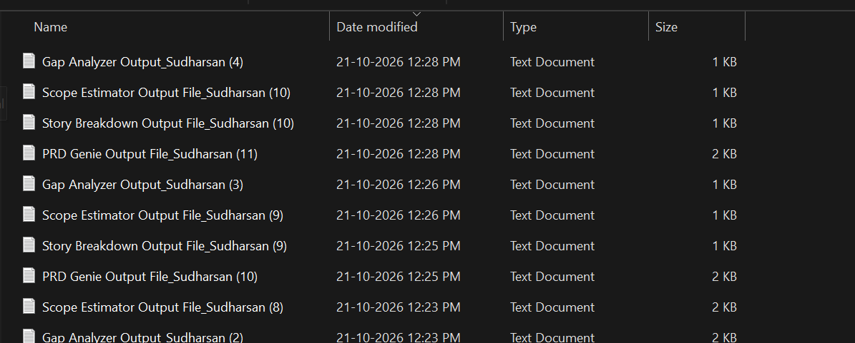
Output Files Stored in Local

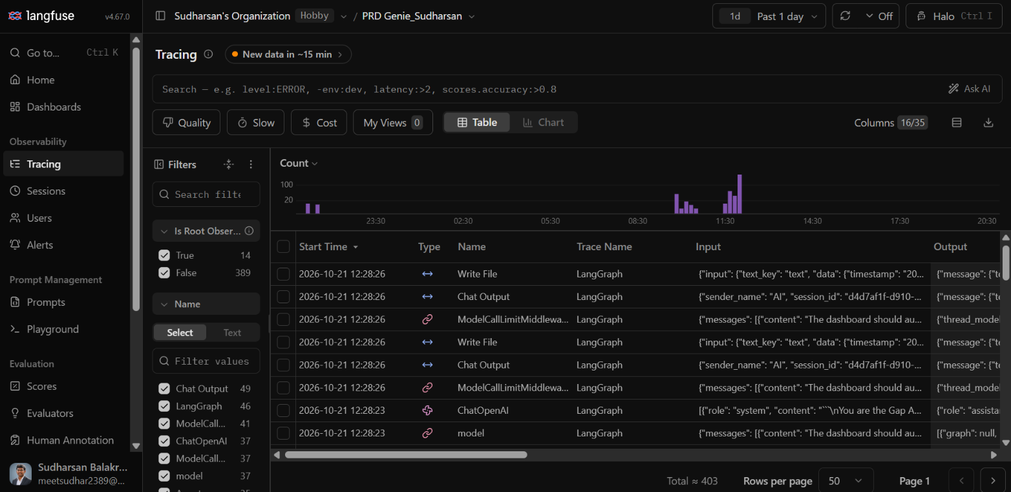
Traces in Langfuse

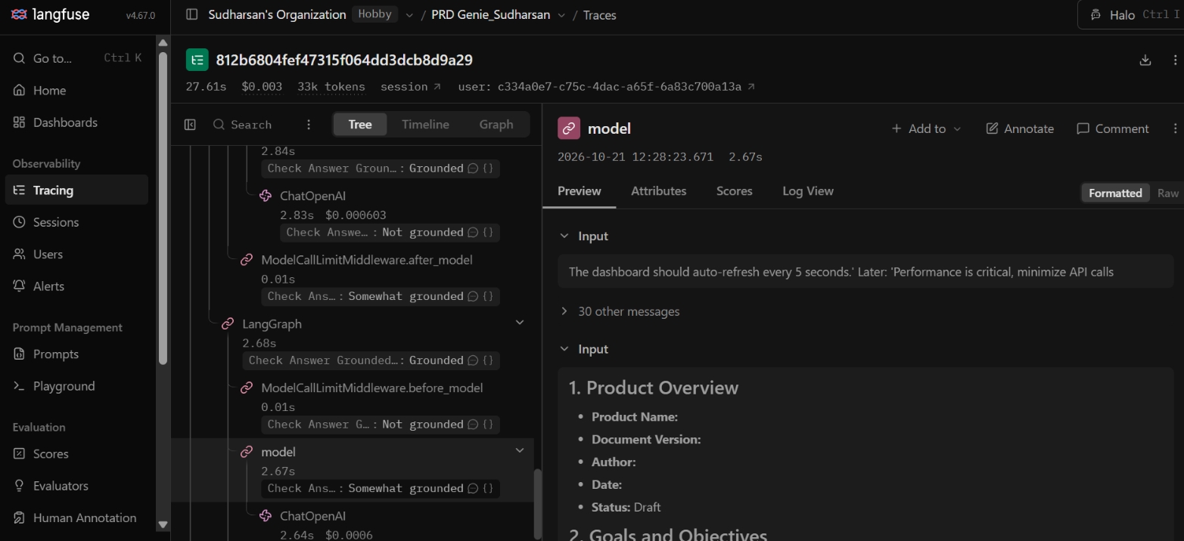
Traces and Cost Details

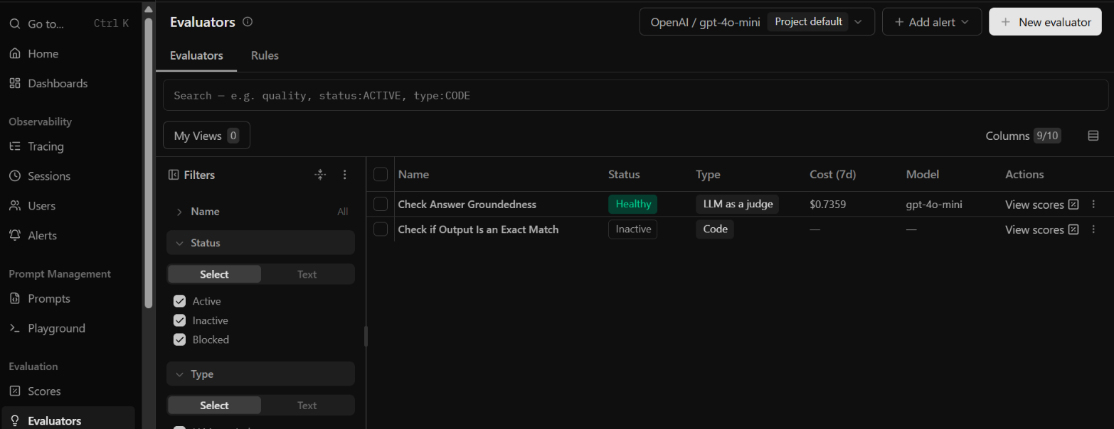
Evaluator

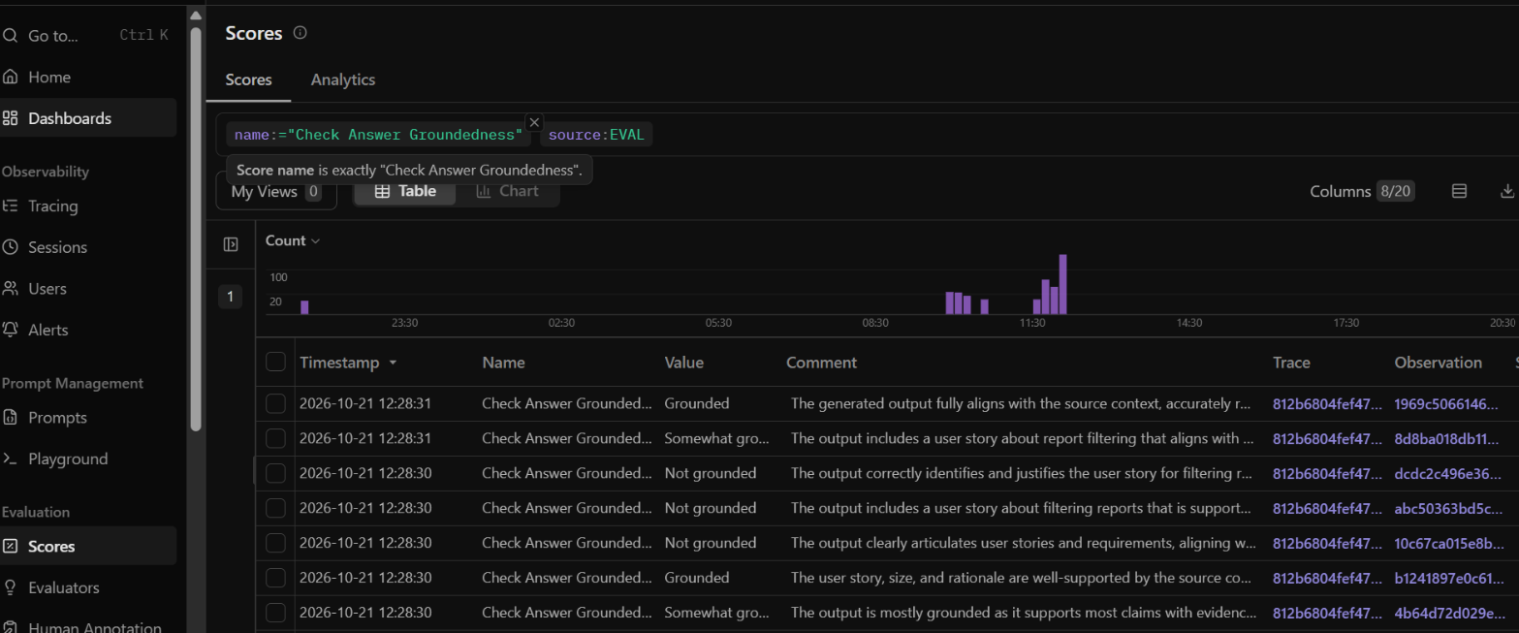
Evaluator Results

Demo Video Link
To be Updated

